GenAI Solution Architecture for Guided Product Discovery

This document outlines a step-by-step explanation of the GenAI-based solution for guided product discovery, aligned with Azure resources. The goal is to help salespeople quickly and accurately match customer needs with the appropriate electrical products from a large catalog.

# Solution Architecture Diagram

The following diagram illustrates the high-level architecture of the GenAI solution:

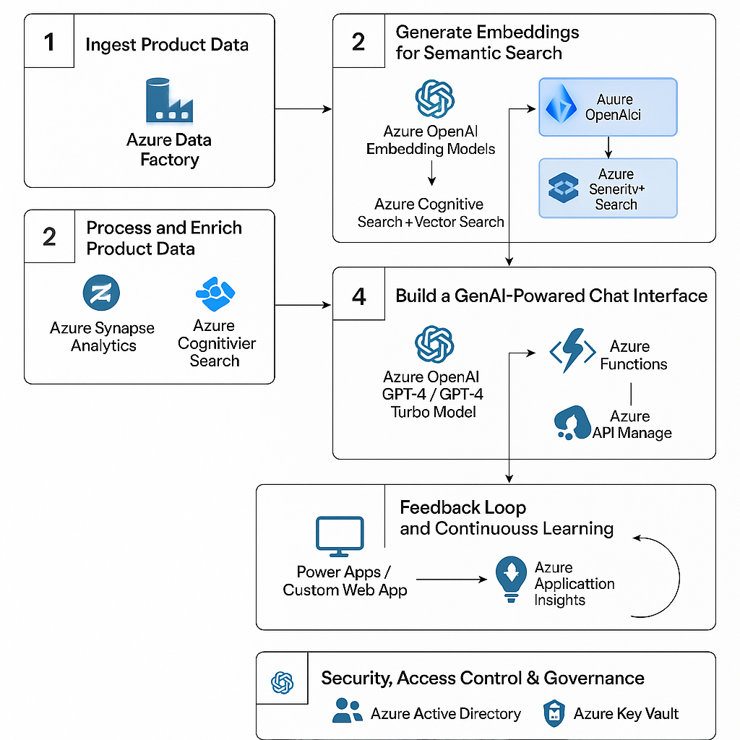

## Step 1: Ingest Product Data

* - Azure Data Factory collects product data from databases, vendor portals, and files (PDFs, CSVs, etc.).
* - Centralizes raw data into Azure Data Lake or other storage for unified access.

## Step 2: Process and Enrich Product Data

* - Azure Synapse Analytics cleans, transforms, and normalizes product attributes.
* - Azure Cognitive Search indexes processed data for hybrid search (keyword + semantic).

## Step 3: Generate Embeddings for Semantic Search

* - Azure OpenAI converts product texts and queries into embeddings.
* - Azure Cognitive Search with Vector Search matches customer queries to product vectors.

## Step 4: Build a GenAI-Powered Chat Interface

* - Azure OpenAI (GPT-4) interprets queries and provides recommendations.
* - Azure Functions & API Management handle backend logic securely.

## Step 5: User Interface for Salespeople

* - Power Apps or custom web app provides a clean interface for query input and product suggestions.
* - Salespeople can interact in real-time with the assistant.

## Step 6: Feedback Loop and Continuous Learning

* - Azure Application Insights tracks query logs and feedback.
* - Data used to fine-tune prompts, improve accuracy, and retrain embeddings.

## Step 7: Security, Access Control & Governance

* - Azure Active Directory manages user roles and permissions.
* - Azure Key Vault securely stores credentials and secrets.